

**FACULTY OF ENGINEERING**

**COMPUTER ENGINEERING DEPARTMENT**

**2023-2024 SPRING**

**PROGRAMMING LANGUAGES**

**PROJECT**

Furkan BULUT 210316011

Binnur SÖZTUTAR 210316084

Barış KOÇ 210316042

Evening Class

**INTRODUCTİON**

In this project, we designed a special programming language that includes Turkish keywords and structures. The main purpose of this language is to show how programming language concepts can be adapted to specific linguistic conditions. This report summarizes the language's grammar in BNF format, includes state diagrams of important language constructs, and provides sample code examples. In addition, the source code for word analysis and parsing was changed to adapt to Turkish letters and keywords, providing syntax and semantic information appropriate to the designed language. C was used to implement it.

Properties of Languages :

BNF Structure of Language :

<program> -> <start_op> <else_ifadesi> <finish_op> | <start_op> <var>

<assign_op> <expr> <finish_op> | <start_op> <while_ifadesi> <finish_op>

<else_ifadesi> -> <eger> <var> <karsilastirma_op> <factor><ise> <var>

<assign_op> <factor> <degilse> <var> <assign_op> <factor>

<start_op> -> <

<finish_op> -> >

<var> -> <type> <id>

<type> -> int

<id> -> <letter> <id2>

<id2> -> <letter> <id2> | <digit> <id2> | ε

<expr> -> <term> - <expr> | <term> + <expr> | <term>

<term> -> <factor> / <term> | <factor> * <term> | <factor>

<factor> -> <digit> <factor> | <digit>

<digit> -> 0 | 1 | 2 | 3 | 4 | 5 | 6 | 7 | 8 | 9

<letter> -> a | b | c | ç | d | e | f | g | ? | h | ? | i | j | k | l | m | n | o | ö | p | r | s | ? | t | u | ü | v | y | z

<assign_op> -> =

<ise>-> ise

<degilse> -> degilse

<eger> -> eger

<karsilastirma_op> -> < | > | <= | >= | == | !=

<while_ifadesi> -> <while_op> <var> <karsilastirma_op> <factor> <do_op> <program>

<while_op> -> while

<do_op> -> do

STATE DIAGRAM

**STATE DIAGRAM**

**<program>**

**|**

<start_op>

**|**

**[<]**

**|**

**<İfelsekontrol>**

**nextToken**

┌─────────────┴────────────────────────┐

**eger <var>**

**| |**

**<eger_ifadesi> <assign_op>**

**| |**

**> <expr>**

**|** ┌────────────┴───────────┐

**nextToken==EGER nextToken==WHILE nextToken==VAR**

**| | |**

**<eger_ifadesi> <while_ifadesi> <**handle_var_sequence();>

| |

**<finish_op>** **<finish_op>**

**| |**

**<end> <end>**

<else_ifadesi> <var>

| |

<eger> <start>

| |

<var> <type>

| |

<karsilastirma_op> <ıd>

| |

<factor> <end>

┌─────────────┴───────────┐

<ise> <degilse>

| |

<program> <program>

| |

<var> <var>

| |

<assign_op> <assign_op>

| |

<factor> <factor>

| |

<end> <end>

**<while_ifadesi>**

**|**

**Giris --> <while_ifadesi>**

**|───────────|───────────|─────────────|─────────|───────|──────────|**

**<while_op> <var> <karsilastirma_op> <factor>. <do_op> <program>**

**| | | | | |**

**Giris --> <while_op> ("Giris --> <karsilastirma_op> Giris --> <do_op>**

**| | |**

**nextToken==WHILE nextToken == ASSIGN_OP nextToken == DO**

**┌────┴───────────────┐ ┌────┴───────────────┐ ┌────┴────────────────┐**

**değilse ise değilse ise. değilse ise**

**| | | | | |**

**Hata: <while_op> bekleniyor. <lex>. Hata: <karsilastirma_op> bekleniyor <lex> Hata: <do_op> bekleniyor <lex>**

**| | | | | |**

**<err> Cikis --> <while_op>\ <err> Cikis --> <karsilastirma_op> <err>** Cikis --> <do_op>

**<LEFT_PAREN>**: This node represents a left parenthesis symbol "(".

**<RIGHT_PAREN>**: This node represents a right parenthesis symbol ")".

**<ADD_OP>**: This node represents an addition operator symbol "+".

**<SUB_OP>**: This node represents a subtraction operator symbol "-".

**<MULT_OP>**: This node represents a multiplication operator symbol "*".

**<DIV_OP>**: This node represents a division operator symbol "/".

**<ASSIGN_OP>**: This node represents to assign a value to a variable. operator symbol "=".

**<START_OP>:** This node represent to marks the beginning of a block or a program segment. Operator symbol “ < ”

**<FINISH_OP>**: This node represents a marks the end of a block or a program segment assigned operator symbol " > ".

**<karsilastirma_op>** = < | > | <= | >= | == | !=

**<eof>**: This node represents the end of the input sequence, denoted by the symbol "EOF

**<digit>** : 0 | 1 | 2 | 3 | 4 | 5 | 6 | 7 | 8 | 9

**<letter>** : a | b | c | ç | d | e | f | g | ? | h | ? | i | j | k | l | m | n | o | ö | p | r | s | ? | t | u | ü | v | y | z

CODE BLOCKS AND FUNCTİONS

**\*\*\*main Function:**

main(): It is the entry point of the program. It opens the input file and performs token operations by calling the lex() and program() . setlocale(LC_ALL, "Turkish"); : ets the language and character set settings of the program to Turkish. This ensures correct processing of Turkish characters. The file is opened, but if not, an error message is received. Here do { lex(); program(); } while (nextToken != EOF);: lex and program functions are called and repeated until the end of the input file. The end of the file is reached and the program ends.

**Code Blocks of main Function:**

/* Main driver */

int main() {

setlocale(LC_ALL, "Turkish");

if ((in_fp = fopen("ex4.txt", "r")) == NULL)

printf("Dosya Okuma Hatas?. \n");

else {

getChar();

do {

lex();

program();

} while (nextToken != EOF);

}

}

**\*\*\*Fonction of ‘program’ :**

‘start_op’ is called and the start of the program is processed. The nested while_statement and if_statement are called. The program is terminated with ‘finish_op’ .

**Code Blocks of program Function:**

/* Custom functions */

/* <program> -> <start_op> <var> <assign_op> <expr> <finish_op> | <starp_op> <while_ifadesi> <finish_op> | <star_op> <ifelse> <finish_op> */

// Main program

void program() {

printf("Program Baslatiliyor...\n");

start_op();

ifelsekontrol();

// Function to handle repetitive VAR checks

void handle_var_sequence() {

while (nextToken == VAR) {

var();

assign_op();

expr();

if (nextToken == WHILE) {

while_ifadesi();

return;

}

if(nextToken == EGER) {

eger_ifadesi();

return;

}

if (nextToken == VAR) {

handle_var_sequence();

}

}

}

if (nextToken == WHILE) {

while_ifadesi();

} else if (nextToken == VAR) {

handle_var_sequence();

}

while (nextToken != FINISH_OP) {

ifelsekontrol();

handle_var_sequence();

}

finish_op();

}

**\*\*\*Fonction of ‘var’ :**

'type' and 'id' are called with this function.

**Code Blocks of var Function:**

/* <var> -> <type> <id> */

void var() {

printf("Giris --> <var>\n");

type();

id();

printf("Cikis --> <var>\n");

}

**Fonction of ‘factor’ :**

‘digit ‘is called and if nextToken is ‘INT_LIT’, ‘lex ‘is called.

**Code Blocks of factor Function:**

/* <factor> -> <digit> <factor> | <digit> */

void factor() {

printf("Giris --> <factor>\n");

digit();

if (nextToken == INT_LIT) {

lex();

}

printf("Cikis --> <factor>\n");

}

**Fonction of ‘karsilastirma_op’ :**

If 'nextToken' is 'ASSIGN_OP' then 'lex' is called, otherwise it gives an error message.

**Code Blocks of ‘karsilastirma_op’ Function:**

/* <karsilastirma_op> -> < | > | <= | >= | == | != */

void karsilastirma_op() {

printf("Giris --> <karsilastirma_op>\n");

if (nextToken == ASSIGN_OP) {

lex();

}

else {

printf("Hata: <karsilastirma_op> bekleniyor.\n");

err();

}

printf("Cikis --> <karsilastirma_op>\n");

**Fonction of ‘while_ifadesi’ :**

**Code Blocks of ‘‘while_ifadesi’ Function:**

/* <while_ifadesi> -> <while_op> <var> <karsilastirma_op> <factor> <do_op> <program> */

void while_ifadesi() {

printf("Giris --> <while_ifadesi>\n");

while_op();

var();

karsilastirma_op();

karsilastirma_op();

factor();

do_op();

program();

printf("Cikis --> <while_ifadesi>\n");

}

**Fonction of ‘while_op’ :**

If 'nextToken' is 'WHILE' then 'lex' is called, otherwise it gives an error message

**Code Blocks of ‘‘while_op’ Function:**

/* <while_op> -> while */

void while_op() {

printf("Giris --> <while_op>\n");

if (nextToken == WHILE) {

lex();

} else {

printf("Hata: <while_op> bekleniyor.\n");

err();

}

printf("Cikis --> <while_op>\n");

}

**Fonction of ‘do_op’ :**

If 'nextToken' is 'DO' then 'lex' is called, otherwise it gives an error message.

**Code Blocks of ‘do_op’ Function:**

/* <do_op> -> do */

void do_op() {

printf("Giris --> <do_op>\n");

if (nextToken == DO) {

lex();

} else {

printf("Hata: <do_op> bekleniyor.\n");

err();

}

printf("Cikis --> <do_op>\n");

}

**Fonction of ‘degilse’:**

The function checks if the variable 'nextToken' is 'NOT'.

If 'nextToken' is 'NOT', the next token is processed by calling the 'lex' function.

If 'nextToken' is 'NOT', an error message is printed and the 'err' function is called.

**Code Blocks of ‘degilse’ Fonction:**

/* <degilse> -> degilse */

void degilse() {

printf("Giris --> <degilse>\n");

if (nextToken == DEGILSE) {

lex();

}

else {

printf("Hata: <degilse> bekleniyor.\n");

err();

}

printf("Cikis --> <degilse>\n");

}

**Fonction of ‘ise’:**

This function checks for the 'if' keyword. The function checks if the variable 'nextToken' is 'ISE'. If 'nextToken' is 'ISE', the next token is processed by calling the 'lex' function. If 'nextToken' is not 'ISE', an error message is printed and the 'err' function is called.

**Code Blocks of ‘ise’ Fonction:**

void ise() {

printf("Giris --> <ise>\n");

if (nextToken == ISE) {

lex();

}

else {

printf("Hata: <ise> bekleniyor.\n");

err();

}

printf("Cikis --> <degilse>\n");

}

**Fonction of ‘ifelsekontrol’ :**

**Code Blocks of ‘ifelsekontrol’ Fonction:**

void ifelsekontrol() {

if (nextToken == EGER) {

eger_ifadesi();

} else if (nextToken == WHILE) {

while_ifadesi();

}

}

**Fonction of ‘isCorrectDataType’ :**

This function checks whether a given lexeme is the correct data type. If the lexeme is 'number', the function returns 1.

Otherwise, the function returns 0.

**Code Blocks of ‘isCorrectDataType’ Fonction:**

correct data type func for if else and program

/* correct data type func for if else and program */

int isCorrectDataType(char* lexeme) {

if (strcmp(lexeme, "sayi") == 0) {

return 1;

}

else {

return 0;

}

}

**Fonction of ‘err’ :**

This function is called when an error occurs. The function prints an error message and terminates the program

**Code Blocks of ‘err’ Fonction:**

/* Error function */

void err() {

printf("Hata fonksiyonu calisti. \n");

exit(0);

}

/* End of custom functions */

/* custome funcs for if else */

**Fonction of ‘eger_ifadesi’ :**

**Code Blocks of ‘eger_ifadesi’ Fonction:**

/* <eger_ifadesi> -> <eger> <var><karsilastirma_op> <factor> <dogruluk_kontrol> <degilse> <dogruluk_kontrol> <finish_op> */

void eger_ifadesi() {

printf("Giris --> <eger_ifadesi>\n");

lex();

var();

karsilastirma_op();

karsilastirma_op();

factor();

ise();

program();

degilse();

program();

printf("Cikis --> <eger_ifadesi>\n");

}

These codes are written to recognize and process the "if statement" structure. The **eger_ifadesi** function processes each part of this statement one by one and invokes the rest of the program to execute the if-else logic. Additionally, the **err** function is called in case of errors, terminating the program.

**Fonction of ‘start_op’ :**

This function is used to recognize and process the < operator. The function checks whether the variable nextToken is START_OP (representing the < operator in this case). If nextToken is 'START_OP', the next token is processed by calling the l'ex()' function. If 'nextToken' is not 'START_OP', an error message is printed and the program is terminated by calling the 'err' function**.**

**Code Blocks of ‘start_op’:**

/* <start_op> -> < */

void start_op() {

printf("Giris --> <start_op>\n");

if (nextToken == START_OP) {

lex();

}

else {

printf("Hata: <start_op> bekleniyor.\n");

err();

}

printf("Cikis --> <start_op>\n");

}

**Fonction of ‘finish_op’ :**

This function is used to recognize and process the > operator. The function checks if the nextToken variable is 'FINISH_OP'. If 'nextToken' is 'FINISH_OP', the next token is processed by calling the 'lex' function. If nextToken 'FINISH_OP' is not present, an error message is printed and the program is terminated by calling the 'err' function. The nextToken value is printed at the beginning of the function for error setting purposes.

**Code Blocks of ‘finish_op’:**

/* <finish_op> -> > */

void finish_op() {

printf("Giris --> <finish_op>\n");

printf("nextToken: %d\n", nextToken);

if (nextToken == FINISH_OP) {

lex();

}

else {

printf("Hata: <finish_op> bekleniyor.\n");

err();

}

printf("Cikis --> <finish_op>\n");

}

**Fonction of ‘getNonBlank’ :**

Finds the first non-space character, skipping the space characters.

**Code Blocks of ‘getNonBlank’ Fonction:**

/* getNonBlank - a function to call getChar until it

returns a non-whitespace character */

void getNonBlank() {

while (isspace(nextChar))

getChar();

}

**Fonction of ‘lex’ :**

This function is used as a simple lexical analyzer and generates tokens for arithmetic expressions. When any token is read, the token type is assigned to the nextToken variable and the function returns this token. If the character is a letter, it can be an identifier. A lexeme consisting of letters and numbers is defined. If the character is a number, it can be a numeric value. By parsing the digits the lexeme is identified and nextToken is set to INT_LIT. Unknown characters and operators are handled with the lookup function. Parses arithmetic expressions by identifying tokens and returns the appropriate token types. When the end of the file is reached, it prints the message that the program is finished.

**Code Blocks of ‘lex’ Foction:**

/* lex - a simple lexical analyzer for arithmetic

expressions */

int lex() {

lexLen = 0;

getNonBlank();

switch (charClass) {

/* Parse identifiers */

case LETTER:

addChar();

getChar();

while (charClass == LETTER || charClass == DIGIT) {

addChar();

getChar();

}

/* If the read lexeme is a variable, it assigns the value VAR to the nextToken

If the read lexeme is a identifier, it assigns the value IDENT to the nextToken

(The isEqual function is defined below the code block) */

if (isCorrectDataType(lexeme)) {

nextToken = VAR;

}

else {

nextToken = IDENT;

}

//break;

if (strcmp(lexeme, "eger") == 0)

nextToken = EGER;

else if (strcmp(lexeme, "ise") == 0)

nextToken = ISE;

else if (strcmp(lexeme, "degilse") == 0)

nextToken = DEGILSE;

else if (strcmp(lexeme, "e?ittir") == 0)

nextToken = KARSILASTIRMA_DURUMU;

else if (strcmp(lexeme, "b?y?kt?r") == 0)

nextToken = KARSILASTIRMA_DURUMU;

else if (strcmp(lexeme, "k???kt?r") == 0)

nextToken = KARSILASTIRMA_DURUMU;

else if (strcmp(lexeme, "surece") == 0)

nextToken = WHILE;

else if (strcmp(lexeme, "yap") == 0)

nextToken = DO;

else {

}

break;

/* Parse integer literals */

case DIGIT:

addChar();

getChar();

while (charClass == DIGIT) {

addChar();

getChar();

}

nextToken = INT_LIT;

break;

/* Parentheses and operators */

case UNKNOWN:

lookup(nextChar);

getChar();

break;

/* EOF */

case EOF:

nextToken = EOF;

lexeme[0] = 'E';

lexeme[1] = 'O';

lexeme[2] = 'F';

lexeme[3] = 0;

printf("Program bitti.\n");

break;

} /* End of switch */

printf("Sonraki sozcuk: %d, sonraki sozcukbirim %s\n",

nextToken, lexeme);

return nextToken;

} /* End of function lex */

Fonction of ‘type’:

Recognizes and processes the variable type int.

Code Blocks of. ‘type’ Fonction:

/* <type> -> int */

void type() {

printf("Giris --> <type>\n");

if (nextToken == VAR) {

lex();

}

else {

printf("Hata: <type> bekleniyor.\n");

err();

}

printf("Cikis --> <type>\n");

}

Fonction of ‘id’:

Recognizes an identifier and calls the necessary functions to process it.

Code Blocks of. ‘id’ Fonction:

/* <id> -> <letter> <id2> */

void id() {

printf("Giris --> <id>\n");

letter();

id2();

printf("Cikis --> <id>\n");

}

Fonction of ‘id2’:

Processes the rest of the identifier and checks whether it is a letter or a number.

Code Blocks of. ‘id2’ Fonction:

/* <id2> -> <letter> <id2> | <digit> <id2> | ? */

void id2() {

printf("Giris --> <id2>\n");

if (nextToken == IDENT) {

lex();

}

else if (nextToken == INT_LIT) {

lex();

}

else {

printf("Gecersiz karakter. \n");

return;

}

printf("Cikis --> <id2>\n");

}

Fonction of ‘expr:

Recognizes an expression and processes it according to addition or subtraction operators.

Code Blocks of. ‘expr’ Fonction:

/* <expr> -> <term> - <expr> | <term> + <expr> | <term> */

void expr() {

printf("Giris --> <expr>\n");

term();

if (nextToken == SUB_OP) {

lex();

expr();

}

else if (nextToken == ADD_OP) {

lex();

expr();

}

printf("Cikis --> <expr>\n");

}

Fonction of ‘term’:

Recognizes a term and processes it according to multiplication or division operators.

Code Blocks of. ‘term’ Fonction:

/* <term> -> <factor> / <term> | <factor> * <term> | <factor> */

void term() {

printf("Giros --> <term>\n");

factor();

if (nextToken == DIV_OP) {

lex();

term();

}

else if (nextToken == MULT_OP) {

lex();

term();

}

printf("Cikis --> <term>\n");

}

**Fonction of ‘digit’ :**

This function is used to recognize and process a digit.

Code Blocks of. ‘digit’ Fonction:

/* <digit> -> 0 | 1 | 2 | 3 | 4 | 5 | 6 | 7 | 8 | 9 */

void digit() {

printf("Giris --> <digit>\n");

if (nextToken == INT_LIT) {

lex();

}

printf("Cikis --> <digit>\n");

}

**Fonction of ‘letter’ :**

This function is used to recognize and process a letter.

Code Blocks of. ‘letter’ Fonction:

/* <letter> -> a | b | c | ? | d | e | f | g | ? | h | ? | i | j | k | l | m | n | o | ? | p | r | s | ? | t | u | ? | v | y | z */

void letter() {

printf("Giris --> <letter>\n");

if (nextToken == IDENT) {

lex();

}

printf("Cikis --> <letter>\n");

}

**Fonction of ‘assıgn_op ‘:**

This function defines and processes an assignment operator ('='). If it is not an assignment operator, it prints an error message and terminates the program.

Code Blocks of. ‘assıgn_op’ Fonction:

/* <assign_op> -> = */

void assign_op() {

printf("Giris --> <assign_op>\n");

if (nextToken == ASSIGN_OP) {

lex();

}

else {

printf("Hata : <assign_op> bekleniyor.\n");

err();

}

printf("Cikis --> <assign_op>\n");

}

**Fonction of ‘lookup’ :**

This function is used to recognize operators and parentheses and return appropriate token values. It takes a character as input and determines which token this character corresponds to.

Code Blocks of. ‘lookup’ Fonction:

/* Open the input data file and process its contents

lookup - a function to lookup operators and parentheses

and return the token */

int lookup(char ch) {

switch (ch) {

case '(':

addChar();

nextToken = LEFT_PAREN;

break;

case ')':

addChar();

nextToken = RIGHT_PAREN;

break;

case '+':

addChar();

nextToken = ADD_OP;

break;

case '-':

addChar();

nextToken = SUB_OP;

break;

case '*':

addChar();

nextToken = MULT_OP;

break;

case '/':

addChar();

nextToken = DIV_OP;

break;

/* Assigment operator assigned to "=" */

case '=':

addChar();

nextToken = ASSIGN_OP;

break;

/* Start operator assigned to "<" */

case '{':

addChar();

nextToken = START_OP;

break;

/* Finish operator assigned to ">" */

case '}':

addChar();

nextToken = FINISH_OP;

break;

default:

addChar();

if (strcmp(lexeme, "surece") == 0)

nextToken = WHILE;

else if (strcmp(lexeme, "yap") == 0)

nextToken = DO;

else

nextToken = EOF;

break;

}

return nextToken;

}

**Fonction of ‘addChar’ :**

This function adds the character 'nextChar' to the lexeme array. If lexLen does not exceed 98 characters, 'nextChar' is added and the lexeme is terminated with null. Otherwise, an error message is printed.

Code Blocks of. ‘addChar’ Fonction:

/* addChar - a function to add nextChar to lexeme */

void addChar() {

if (lexLen <= 98) {

lexeme[lexLen++] = nextChar;

lexeme[lexLen] = 0;

}

else

printf("Hata. \n");

}

/* getChar - a function to get the next character of

input and determine its character class */

**Fonction of ‘getChar’ :**

This function takes the next character from the input and determines the class of the character. The character class can be letter (LETTER), digit (DIGIT), unknown (UNKNOWN), or end-of-file (EOF).

Code Blocks of. ‘getChar’ Fonction:

void getChar() {

if ((nextChar = getc(in_fp)) != EOF) {

if (isalpha(nextChar))

charClass = LETTER;

else if (isdigit(nextChar))

charClass = DIGIT;

else charClass = UNKNOWN;

}

else

charClass = EOF;

}

Example Inputs and Outputs Of The Language:

ERROR EXAMPLES

INPUT: { sayi bar 35 + 2 }

OUTPUT:

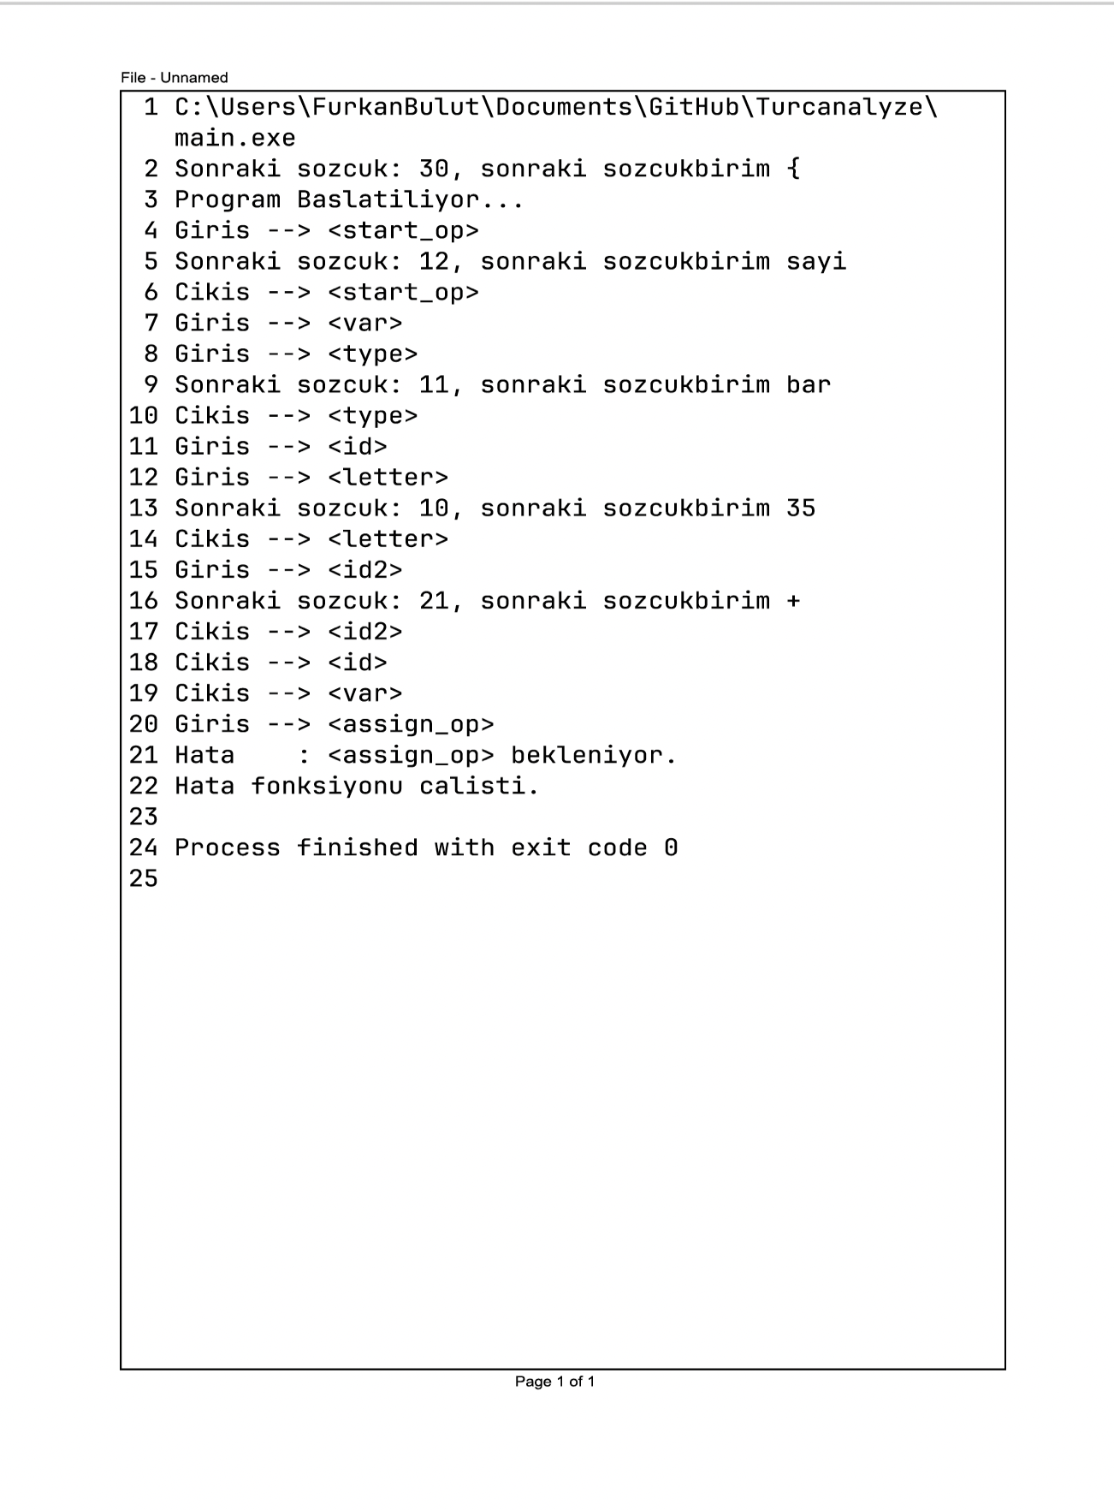

INPUT: {

eger sayi 5 == 5 ise { surece sayi == 3 yap { sayi furkan = 5 }}

degilse {

sayi deneme = 10

}

eger sayi == 5 ise { surece sayi == 3 do { sayi furkan = 5 }}

}

OUTPUT:

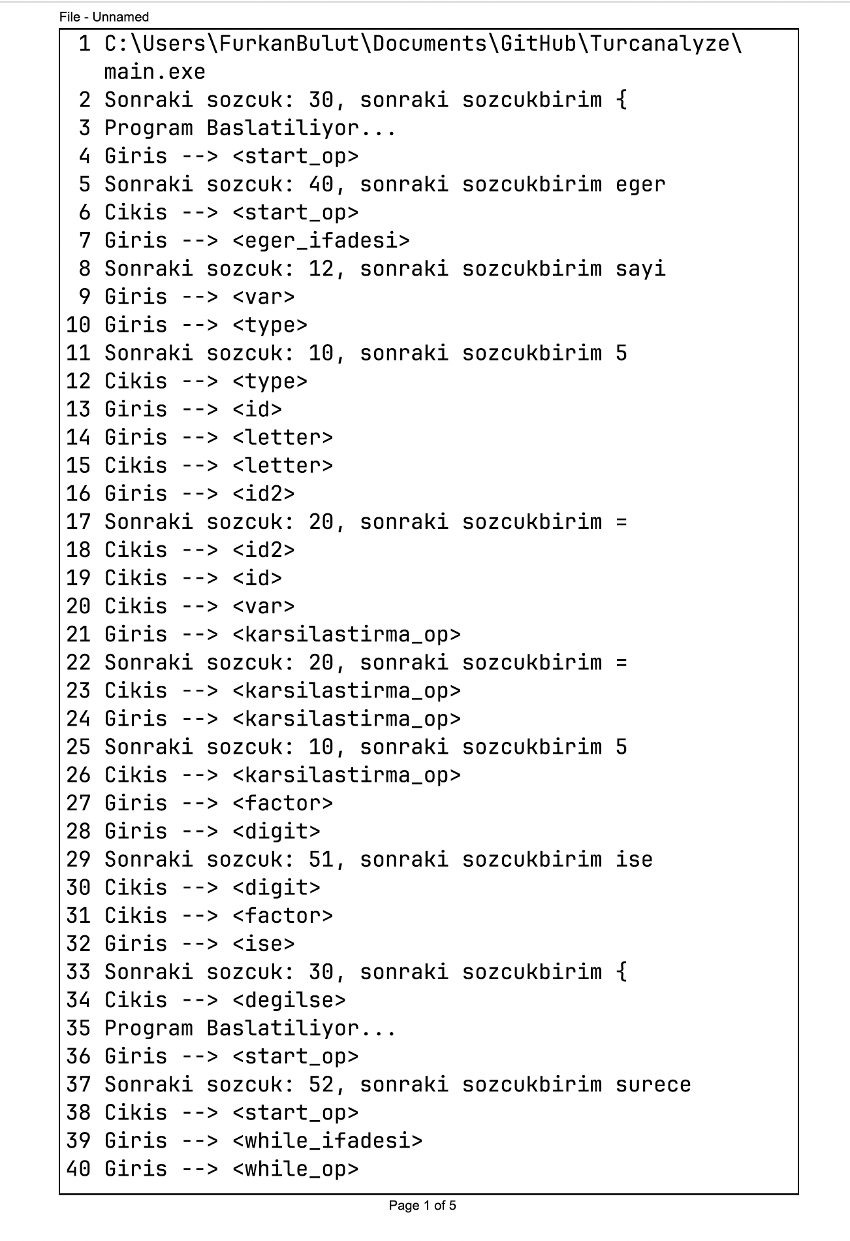

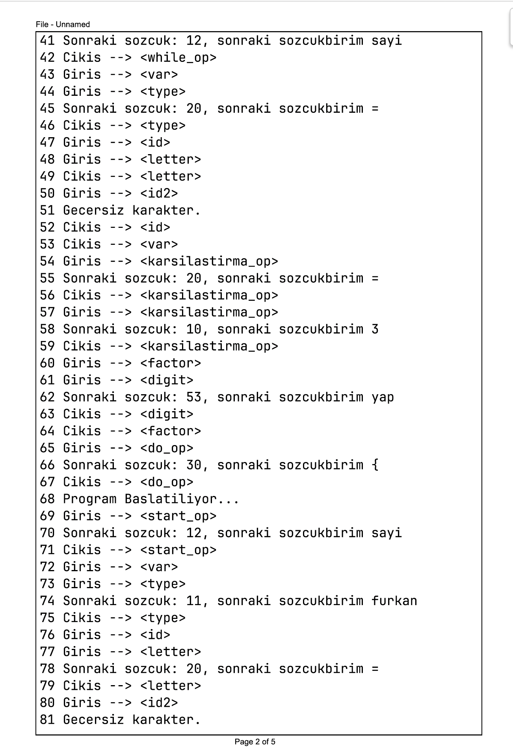

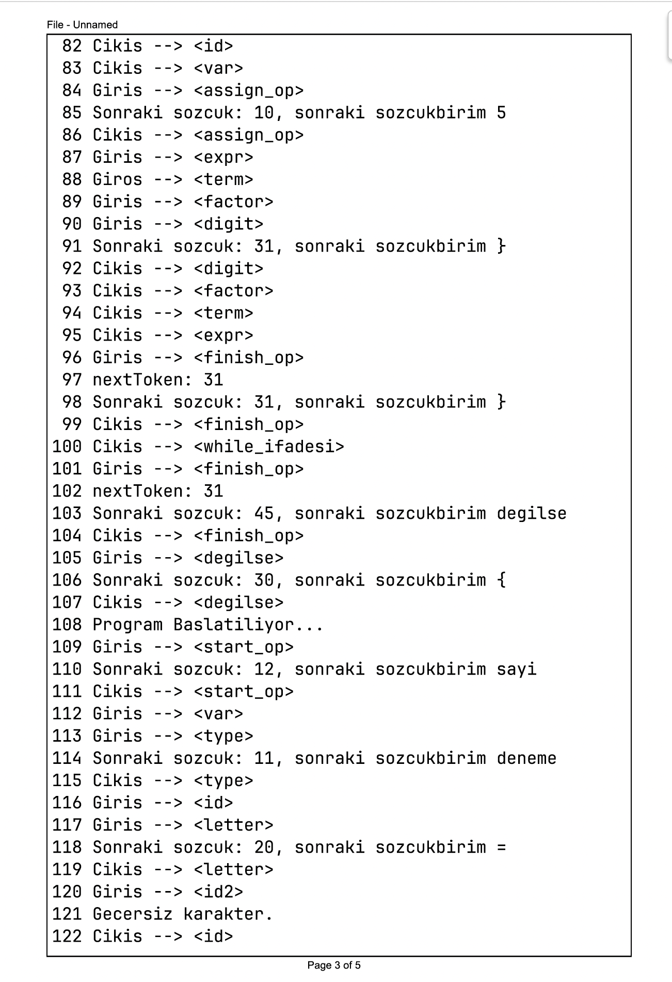

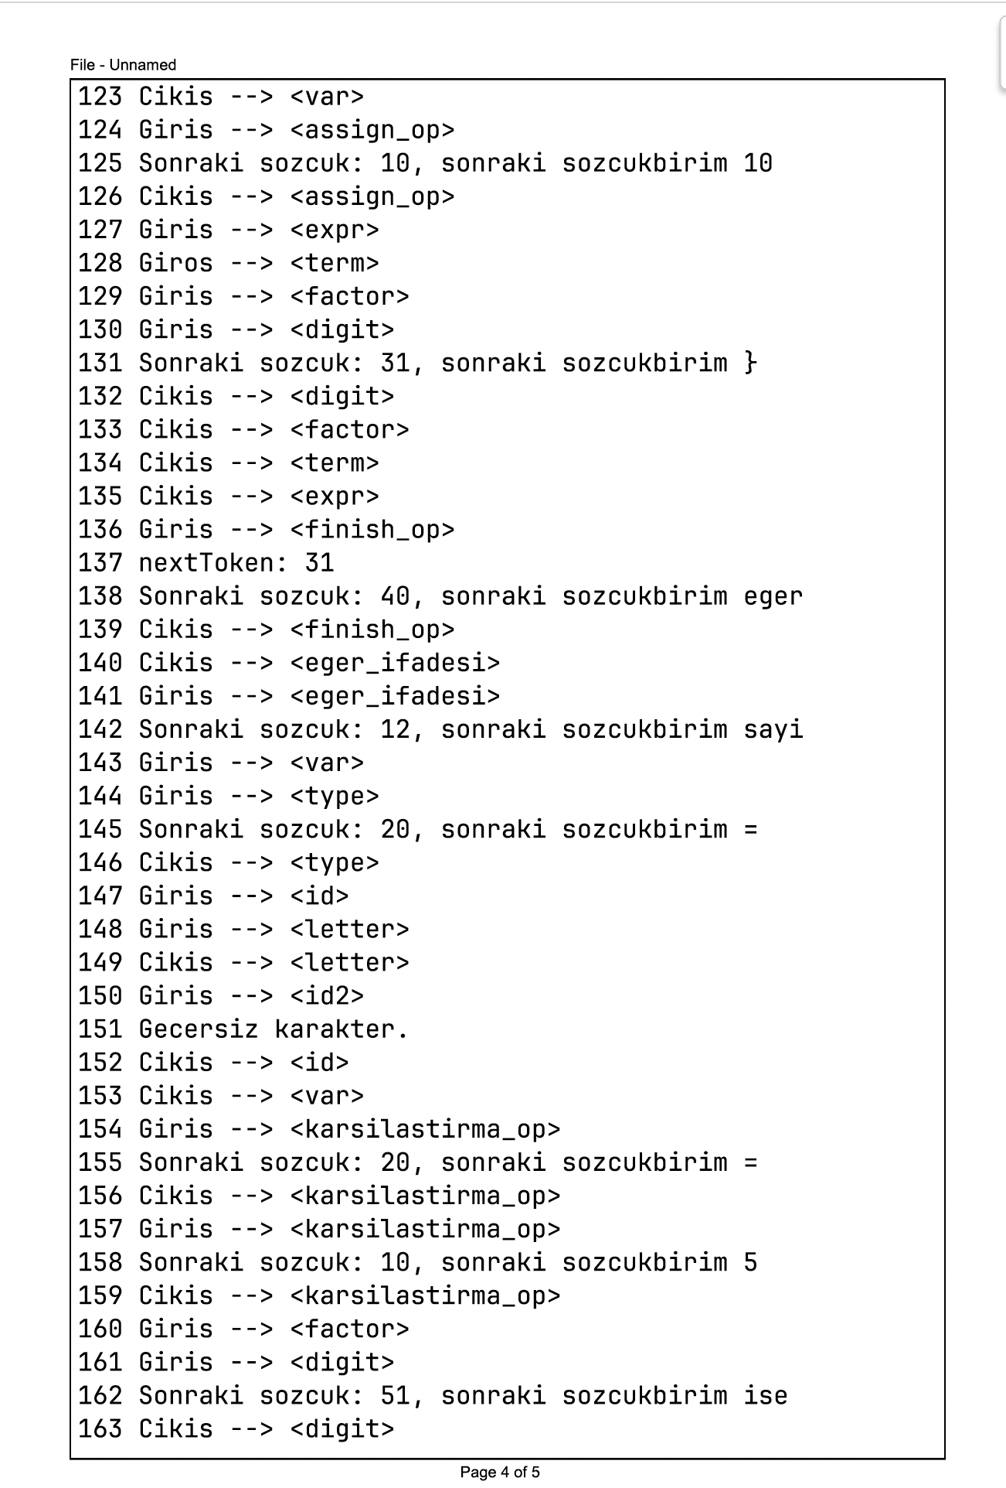

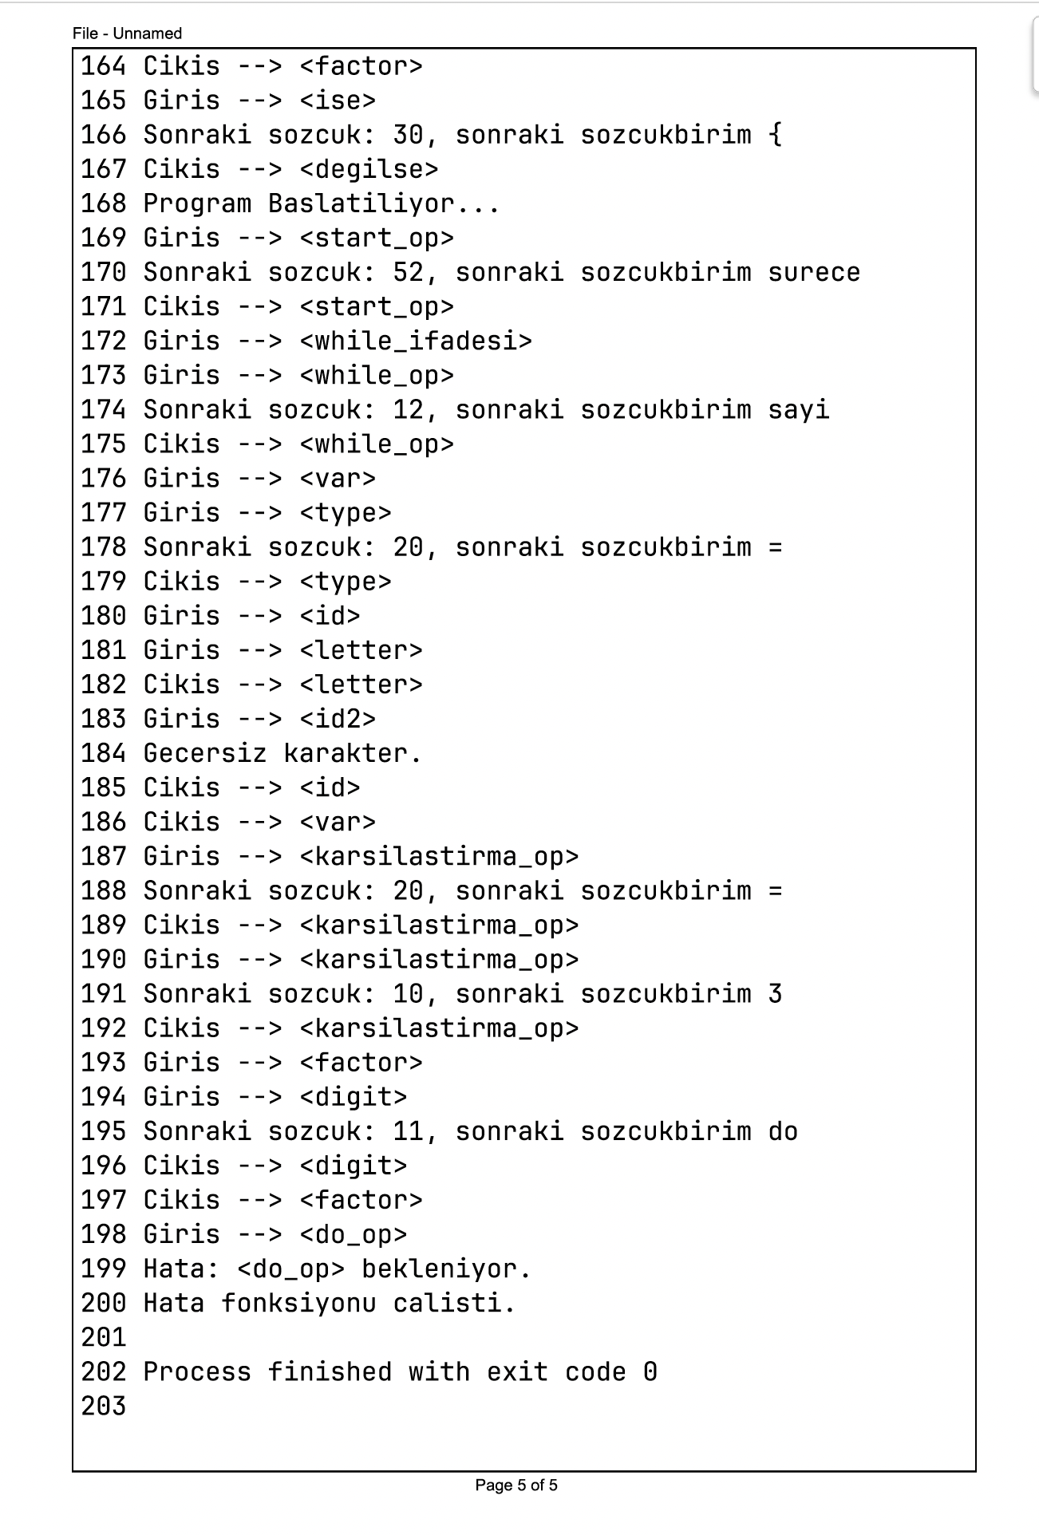

EXAMPLES THAT DO NOT CAUSE ERRORS

INPUT:

{eger sayi bar˝˛ == 5 ise { sayi bar˝˛ = 6 } degilse { sayi bar˝˛ = 4 } sayi ˆ¸i˛ = 88}

OUTPUT: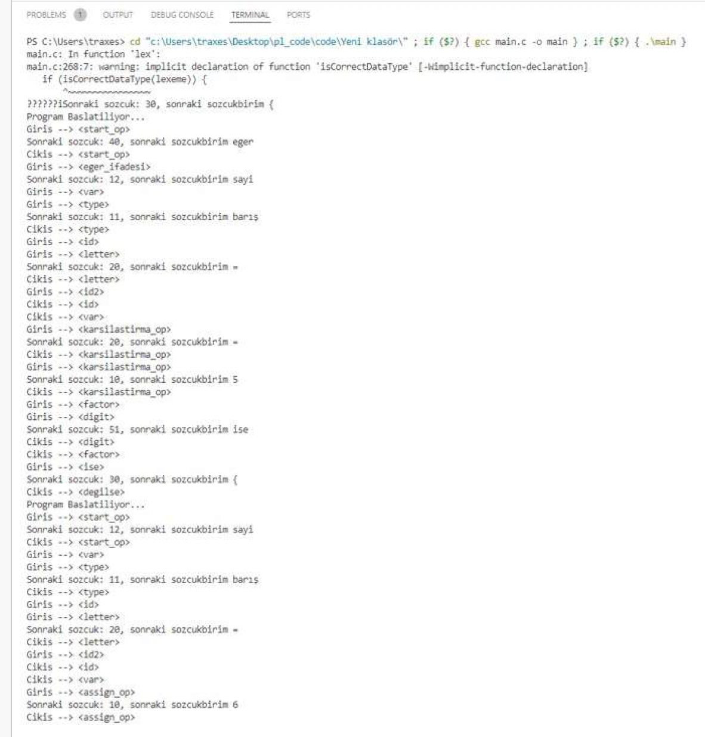

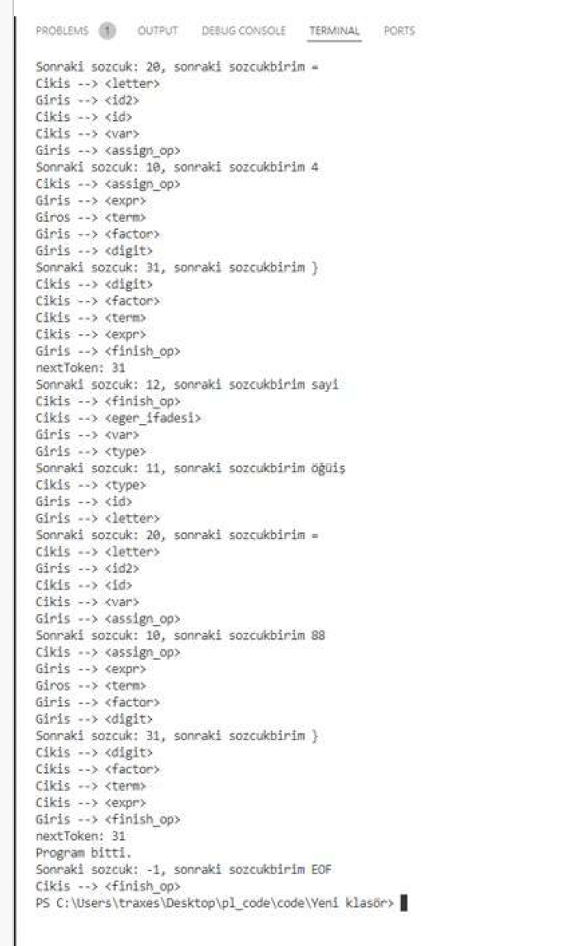

INPUT:

{

sayi x = 3

surece sayi == 3 yap

{

eger sayi x == 5 ise { sayi x = 6 } degilse { sayi x = 4 }

sayi x = 88

surece sayi x == 5 yap

{

sayi deneme = 96

eger sayi x == 5 ise { sayi x = 6 } degilse { sayi x = 55 }

}

eger sayi x == 5 ise { sayi x = 6 } degilse { sayi x = 59599 }

}

eger sayi x == 5 ise { sayi x = 6 } degilse { sayi x = 59599 }

sayi x = 5

}

OUTPUT:

